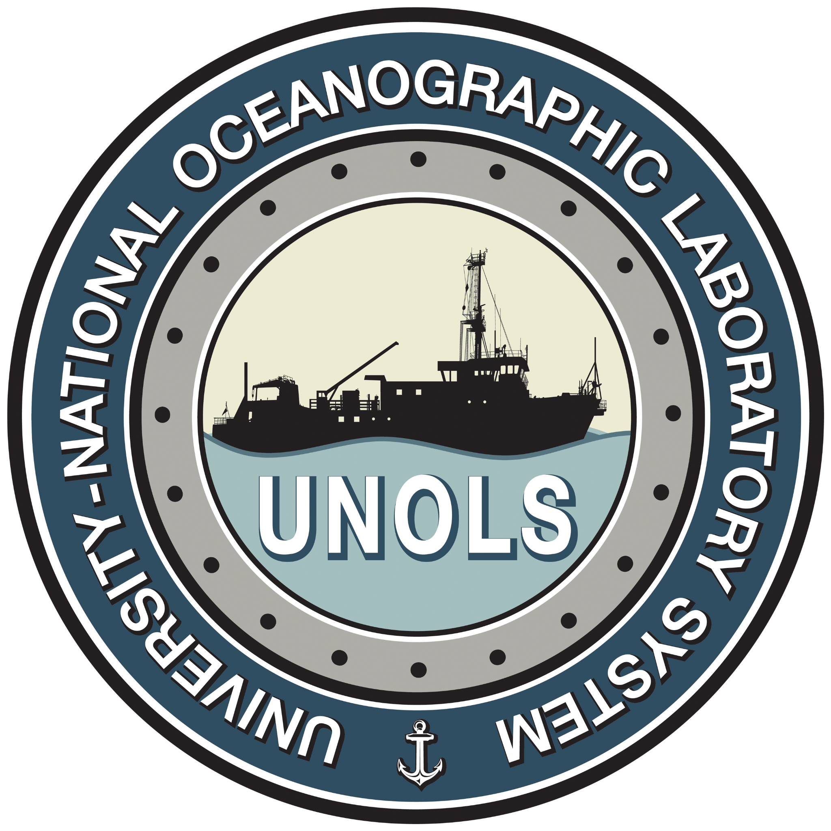

AICC 2025 Summer Meeting

Agenda

Zoom Link:https://washington.zoom.us/j/93233255998?pwd=gdOq135TPKzJybMVt1XnFmbeJXXjQa.1

Zoom Meeting: 932 3325 5998 Passcode: 608208
27 June 2025
1100-1400 Alaska / 1200-1500 Pacific / 1500-1800 Eastern
Times indicated are PDT
Intro
1200 Welcome Laurie Juranek
1205 Chair Report Laurie Juranek
1210 UNOLS Report Doug Russell

Ship Updates
HEALY
1215 2025 Operations Overview LCDR Alex Hamel / HEALY Operations Officer
1225 2025 Dockside Maintenance / 2026 pre-SLEP plans
LCDR Konze / HEALY Engineer Officer
1235 2026 & Beyond Plans LCDR Brian Williams / PACAREA
1245 STARC Report Brendon Mendenhall / STARC
1255 USCG Polar C5IT Report Tom Gomez / Base Seattle C5IT
1305 Arctic Surface Capability Update CDR Phil Baxa / LT Christine McCulla CG-751
1325 Other HEALY topics / issues?

SIKULIAQ
???
1335 2025 Operations Recap / 2026 Ops Outlook Doug Baird / UAF
1345 Tech Update Gabe Matthias / UAF

Agency Updates NOTE – do we need to move earlier due to late time of day?
1355 NSF Frank Rack / NSF OPP
1405 ONR Rob Sparrock / ONR
1415 NOAA David Allen / NOAA

Initiatives
1425 AMRCC Update Carin Ashjian / WHOI
1435 Early Career Scientist Seat on AICC Laurie Juranek

Conclude Meeting
1455 Action Item Review Doug Russell
1500 Close Laurie Juranek

Vers: 1.0-11June2025
DRAFT

