**AICC 2024 Summer Meeting**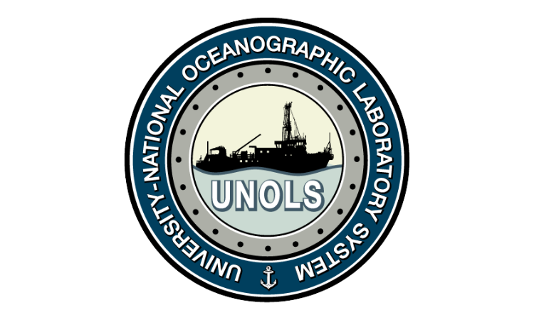

**Wednesday, 26 June 2024**

**0900-1200 Alaska / 1000-1300 Pacific 1300-1600 Eastern**

**Attendees**

| Jackie Grebmeier  Jeff Garrett  Jeffrey Welker  John Farrell  Kate Ruck  Katy Smith  Kristen Cooney  Kyli Cosper  Lee Cooper  Lisa Herbert  LT Christine McCulla  Mark Brass  Maureen Walczak  Meegan Corcoran  Meme Lobecker  Naomi Whitty  R Kipp Shearman  Rachel Murray  Rob sparrock ONR  Scott Harper (ONR)  Shelby Walker - NSF\GEO  Tara M Clemente  Thomas Hummer  Todd Irby NOAA  Woogen, Andrew  Stefani Martynenko  Doug Russell  CGC HEALY  Jesse Spence (NCE)  Lauren Juranek  Anand Hiroji (USM)  Atlantis  Bernie  Bridget Harrell Donze | Carin Ashjian  Chad Caron (Glosten)  Chris Cox NOAA/PSL  Clare Gaffey  Daniel Carlson  David Allen (he/him), NOA  Doug Baird  Eidam, Emily  Emily Shimada  Ethan Roth  Frank Mirobo  Frank Rack  Gay Sheffield  gonim  lan Johns (USCG PACAREA)  Jackie Grebmeier |
| --- | --- |