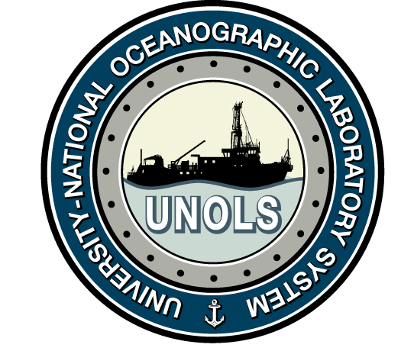
Meeting Agenda

RVOC Safety Committee

30 April 2024

Halifax, Nova Scotia

Tuesday, 30 April 2024 0830-1130 1215-1400

0830 Call Meeting to Order, introductions – Jeff Garrett
0835 Safety committee actions since April 2022 meeting – Jeff Garrett
- Revisions to RVSS approved
- Update of Safety Committee charge
- Appendix A & B training seminar – January 2024
0845 RVSS Waivers granted since last meeting – Jeff Garrett
- Review of synthetic line waiver for Sikuliaq – Rick Trask, Aaron Davis
0900 Lithium-ion batteries: RVSS updates needed?
0930 Appendix A cable/line testing requirements (Section A.5.2) – Rick Trask
1045 Safer Seas requirements – Doug Russell
- Potential Appendix E updates – Emily Shimada
1130 Break for Lunch
1215 Equipment issues:
- Update on new SCBA kits – Jon Swallow
- RPC-90x line control display issues – Josh Eaton
1245 New safety coordinator position in UNOLS Office – Doug Russell
1300 Safety issues identified by NSF Inspection Team – Blake Powell
1320 Any additional issues that merit review by the Safety Committee
1345 Safety Committee Membership review – Jeff Garrett
1400 Meeting concludes
COVE facility tour, RVOC reception

4 April 2024

